MATLAB APP for MPALM Visualization

**User’s Guide**

Contents

MATLAB APP for MPALM Visualization 1

Installation 1

Step 1: Loading the Data 3

1.1 Setting the Parameters 3

1.2 Loading MPALM Results 4

1.3 Drift Correction 5

Step 2: Rendering MPALM Figures 6

2.1 Quick Check on PALM Results 6

2.2 Segmentation of MPALM Data 7

2.3 Rendering MPALM Figures 8

2.4 Additional function for further analysis 9

2.5 Dual channel MPALM-PALM (under development) 11

# Installation

This document outlines the workflow for rendering **MPALM figures** using our **MATLAB App**.

To begin, launch the app by running step4_main_mobilityPALM.mlapp located in the /step4_MPALM_rendering/ folder and add this folder to your MATLAB path. Before using the app, ensure you have installed the following MATLAB toolboxes and add-ons from the official MATLAB website:

* Curve Fitting Toolbox
* Image Processing Toolbox
* Optimization Toolbox
* Parallel Computing Toolbox
* Statistics and Machine Learning Toolbox
* Image Blending Functions (v2.33)
* nanconv (v1.1.0.0)
* Text Progress Bar (CLI & GUI) (v1.3.0.0)

To successfully use this app, you must first process your raw single-molecule data using **UNet** and **DeepSnapTrack**. This process should generate two key files named like this (if default settings were used):

* Blurdata_UNet_mask_MBX_20240620_epoch13_Ch1.mat
* UNet_mask_MBX_20240620_epoch13_Ch1_SR_pred_v3.csv

Then you can launch this app and proceed with the following steps to render MPALM figures. Here we provided our raw data for the displayed figure of paxillin MPALM result as an example, and you can reproduce the rendered image following our step-by-step guidance.

# Step 1: Loading the Data

## 1.1 Setting the Parameters

Before loading the data files, you need to configure the following parameters manually:

* **D-SR constant**: This constant defines the correlation between the diffusion coefficient (*D*) and the square of the SR area.
  + Default values:

**1162** for a 30ms exposure time, **2007** for a 100ms exposure time.

Both of these two values are generated by fitting to simulated dataset. See *Step 3.2: Set Calibration Curve Between PT-area and Diffusivity* in the README.md for detailed instructions.

* **Max allowed photon**: Specifies the upper limit of photons for single localizations.
  + Default: **Inf** (no limit).
* **Min allowed photon**: Specifies the lower limit of photons for single localizations.
  + Default: **0**.
* **Camera pixel size (nm)**: The physical size of camera pixels used for raw data acquisition.
  + Recommended value: **110 nm**, as smaller pixel sizes improve performance.
* **Exposure time (s)**: The time duration for which the camera captures raw data.
  + Default: **0.0305 s** (includes a 0.5ms strobe for the camera).
* **MinLogD and MaxLogD**: Defines the displayed range of diffusion coefficients (*D*) in log10 scale used for showing log10(*D*) distributionof MPALM data in the right panel ***Mobility distribution***.
  + Default values: **-3** and **2**, which stands for 0.001 μm2/s and 100.0 μm2/s.

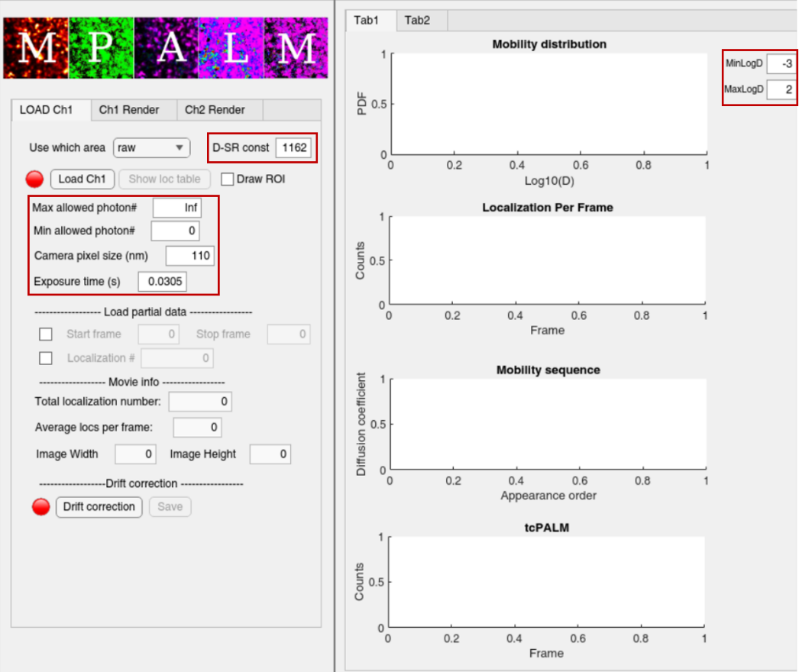

**Figure 1. The main interface of the MPALM app.** The red box highlights the parameters that require user configuration.

## 1.2 Loading MPALM Results

After setting the parameters, click the Load Ch1 button to open the file selection interface. You'll then need to select two specific files mentioned before:

**Blurdata_UNet_mask_MBX_20240620_epoch13_Ch1.mat**

**UNet_mask_MBX_20240620_epoch13_Ch1_SR_pred_v3.csv**

Depending on the size of your dataset, loading may take a few seconds to several minutes. Once completed, **the lamp will turn green** and the primary quantification results will be displayed.

In the left panel, “Movie info” gives you a quick overview of the basic information related to your input data.

The right panel provides two key visualizations about your uploaded MPALM results:

1. **Mobility distribution:** A histogram that displays the distribution of *D* across all localizations. This visualization is essential for helping you choose the appropriate range of *D* values for the color-coding step in MPALM rendering.
2. **Localizations per frame:** This graph serves as a quality control metric, reflecting the stability of your data over the acquisition period.

For a detailed look at your localization data, you can click the Show loc table button, located next to the Load Ch1 button. This will display a table with all the localization information.

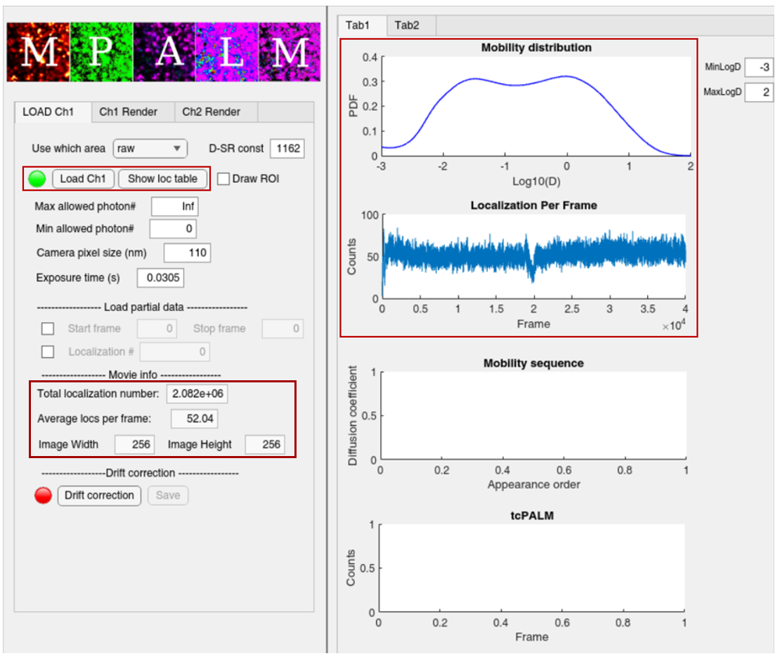

**Figure 2. MPALM App Interface After Loading Data.** The red box highlights the buttons and the place where the primary quantification results are displayed.

## 1.3 Drift Correction

Here we also provided an optional choice for applying drift correction to your raw data. To use this, click the Drift correction button. A new interface will appear, allowing you to choose from three available drift correction methods. Once the process is complete, the lamp will turn green.

1. **Using sequentially captured bulk images:**

This method calculates the cross-correlation between each corresponding time point of sequential bulk images. Ensure that your bulk images are named sequentially, and type in the prefix of your files in selected folder.

1. **Using sequentially captured brightfield images:**

This method optimizes the calculation of cross-correlation between each corresponding time point for sequential **bright field** images (Wester et al). Again, ensure that your bulk images are named sequentially, and type in the prefix of your files in selected folder.

1. **Using all localizations:**

This method calculates the cross-correlation between frames based on all detected localizations. Though some parameters need to be configured manually, no additional files are required for this method.

After you've selected a drift correction method, click the Run! button to process your data. Once the calculation is complete, press Save to store the results.

If you've already saved a drift correction file previously and want to reuse it, be sure to select drift corrected in the "Use which area" block before you load your data.

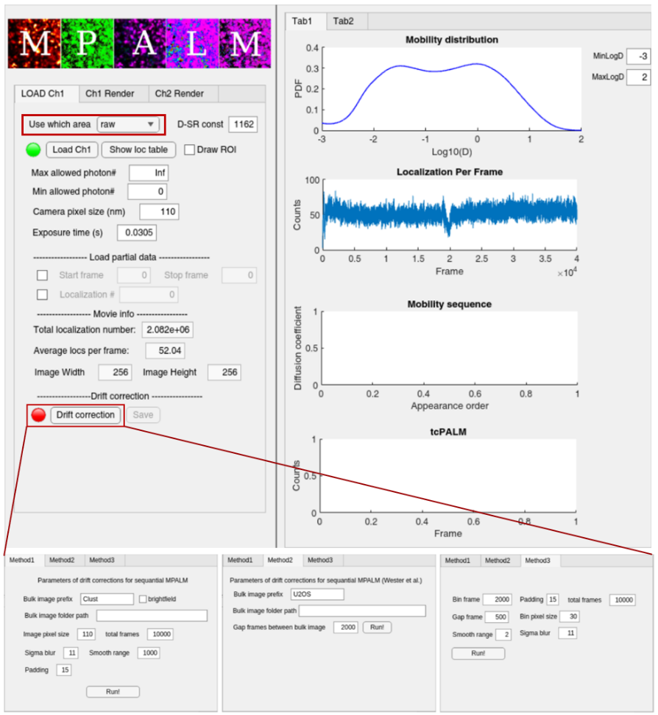`

**Figure 3. Interface of the MPALM app after clicking Drift correction.** The button is indicated in the red box. The following sub figure shows the new interface.

# Step 2: Rendering MPALM Figures

## 2.1 Quick Check on PALM Results

After successfully loading the data, click the Ch1 Render button to begin the rendering process for MPALM figures. Before proceeding, you need to manually configure the following parameters:

* **Render pixel size (nm):** This determines how localizations are binned into pixels in the final figure.
  + Default:30nm.
* **Render sigma (nm):** This defines the size of the Gaussian kernel used during PALM image rendering.
  + Default: 30nm.
* **minDensity and maxDensity:** This specifies the density range in the rendered PALM figure. Pixels with density values beyond this range will be adjusted to the defined minimum/maximum values.

Once you've set the parameters, click the PALM! button to generate the initial PALM figure. A new panel will then appear, allowing you to fine-tune the minimum and maximum density values and adjust the contrast for optimal visualization. With the PALM figure still open, you can also click the Draw ROI button to select a specific region of interest for future analysis.

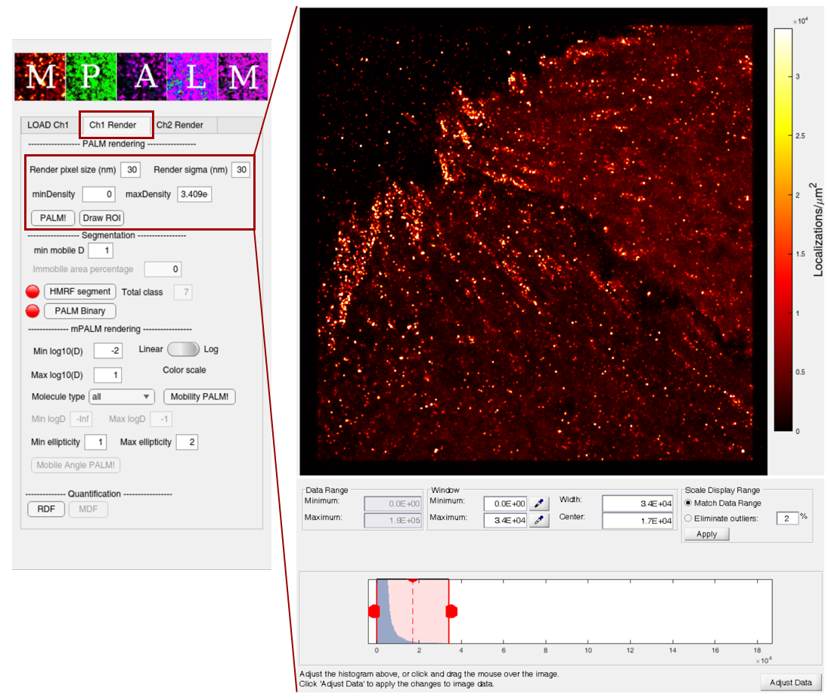

**Figure 4. Interface of the MPALM app when switched to the page of “Ch1 Render”.** The red box indicates parameters that need configuration. The appeared panel after clicking PALM! is shown in right.

## 2.2 Segmentation of MPALM Data

(Optional) This app provides a way of segmentation of MPALM data in case you want to focus on specific subgroup of molecules. First, set the min mobile D to a threshold you're interested in, the further analysis this section will only use the immobile group of your data.

You can then use a hidden Markov model (HMM) based algorithm to segment your data into seven groups based on their density. We used this feature in our paper to analyze chromatin regions defined by H2B. You can run this segmentation by simply clicking the HMRF segment button.

Additionally, you can generate a binary mask specifically for the immobile group by clicking the PALM binary button. A quick visualization of the segmentation will appear, allowing you to fine-tune the minimum and maximum density values and adjust the contrast for optimal visualization. Here the pixels with values higher than your chosen threshold with be identified as the binary mask. The lamp will turn green once the process is complete.

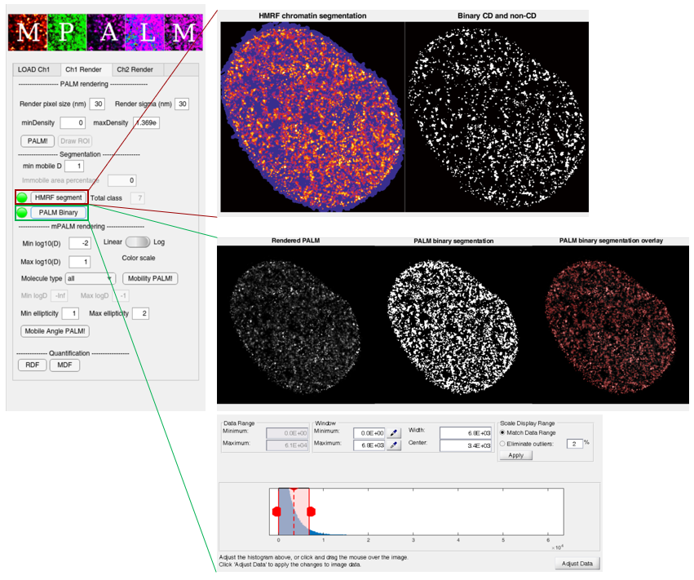

**Figure 5. Example panels when doing segmentation to MPALM data.** Results for HMRF segment and PALM Binary are indicated by red and green boxes, respectively.

## 2.3 Rendering MPALM Figures

This is the final step in generating single channel MPALM figures. Before proceeding, configure the following parameters:

* **Min log(D) and Max log(D):** Used for color mapping in MPALM rendering via the HSV method, where colors represent the diffusion coefficient (*D*). Pixels with *D* values outside this range will not be assigned new colors, i.e., for the predicted log10(*D)* lower than Min log10(D) will be colored as Min log10(D), and for the predicted log10(*D)* higher than Max log10(D) will be colored as Max log10(D). We recommend to set these values based on the log10(*D*) distribution (see 1.2). For the paxillin example, we choose Min log10(D): -2, and Max log10(D) 0.60, which correspond to the rendering *D* range from 0.01 μm2/sto 4.00 μm2/s.
* **Molecule type:** You can choose to render MPALM figures using only the localizations of specific molecules of your interest. When choosing “partial”, you can define Min logD and Max logD under the button of Molecule type to select your customized group of localizations.
* **Color scale:** You can choose either linear or log scale when color-coding your data in MPALM and Diffusion map. By default, we use linear scale.

After setting the parameters, click the Mobility PALM! button to generate your final MPALM figures.

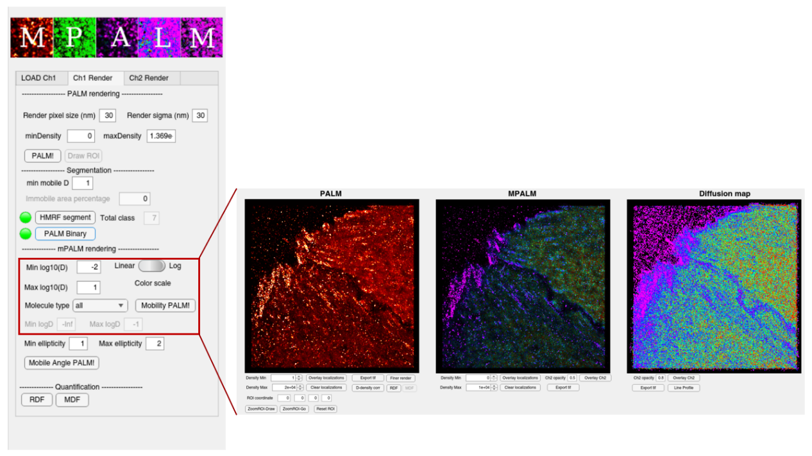

**Figure 6. Arising panels when clicking Mobility PALM! button.** Red box indicates the parameters that need configuration before rendering.

## 2.4 Additional function for further analysis

After the MPALM figures have been generated, you can make additional adjustments to further analyze the results:

* **Density Min** **and** **Density Max:** These two can be defined manually to adjust brightness of the rendered figures (PALM or MPALM).
* **Overlay Localizations and Clear Localizations:** You can use this to overlay the scatter plot of original localizations color-coded by corresponding diffusion coefficient.
* **Export tif:** This allows you to save your rendered figure in .tif format.
* **ZoomROI-Draw/Go and Reset ROI:** You can use ZoomROI-Draw to manually define a region of interest, or you can type in the ROI information (x, y, x_length,and y_length) in ROI coordinate block. In this way the panel will be refreshed and show the zoom in view for PALM, MPALM and Diffusion map synchronously.
* **D-density corr:** A manually defined ROI is required after clicking this button. Then it will calculate the correlation of diffusion coefficient and density and present the fitting result.
* **RDF:** A manually defined ROI is required after clicking this button. Then it will calculate the regional distribution function and present it in form of Ripley’s G and H function.

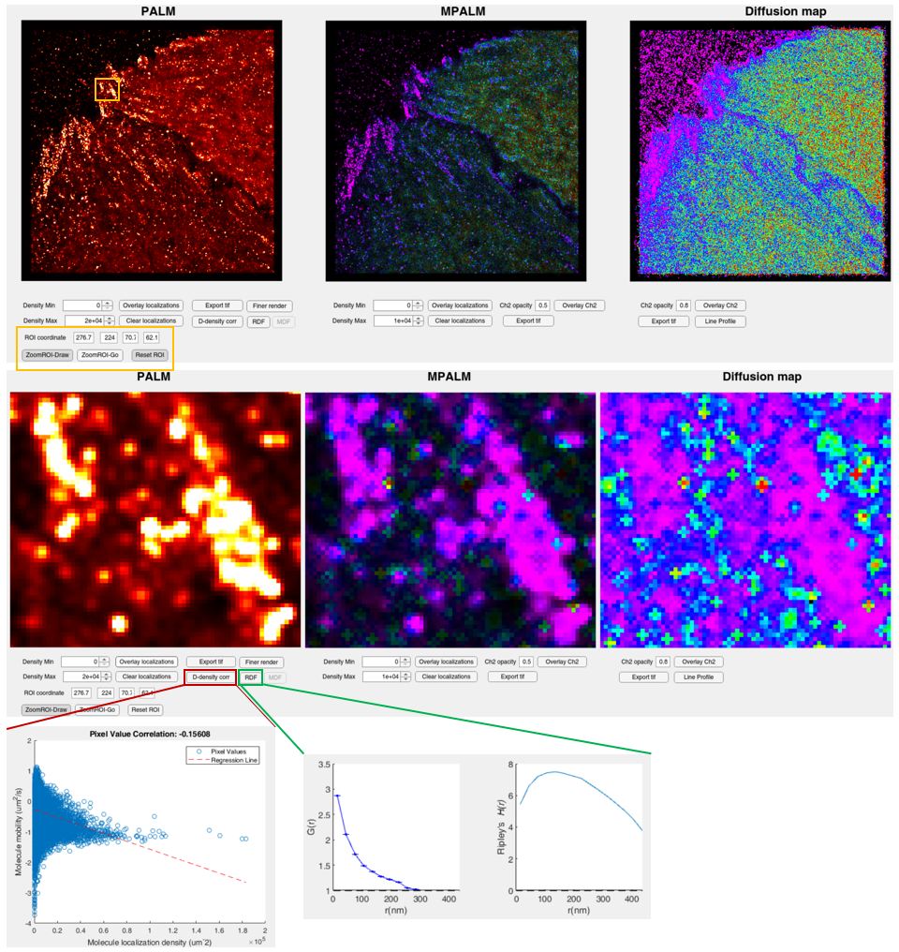

**Figure 7. Interface for performing additional analysis on rendered figures.** The yellow box indicates a representative ROI selected for a zoomed-in view. The red and green boxes highlight the areas for correlation and regional distribution function analysis, respectively.

You can also click Fine render to generate a more detailed view of a specific region of interest. This option requires you to manually define an ROI and render it with a smaller pixel size and Gaussian sigma.

* **Grid size:** This defines the pixel size of fine rendered figure, by default it is set to 2 nm.
* **Gaussian sigma:** This defines the radius of gaussian kernel overlayed for each localization, by default it is set to 10 nm.
* **Density Min** **and** **Density Max:** These two can be defined manually to adjust brightness of the rendered figures (PALM or MPALM). Note that the maximum density is scaled to 1 for fine-rendered figures because a different algorithm is used for PALM rendering in this view.
* **Overlay Localizations and Clear Localizations:** You can use this to overlay the scatter plot of original localizations color-coded by corresponding diffusion coefficient.
* **Export tif:** This allows you to save your rendered figure in .tif format.

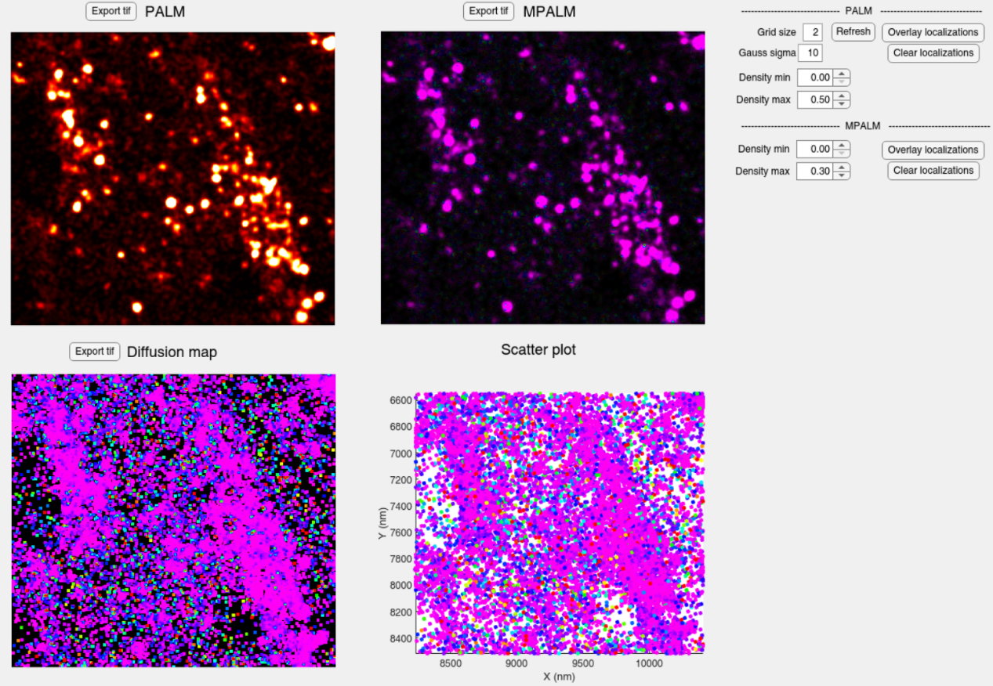

**Figure 6. Interface for fine render function.**

## 2.5 Dual channel MPALM-PALM (under development)

We are still actively developing the dual channel MPALM-PALM, MPALM-MPALM, which we will keep update this manual and app once finished.